# ASTRO 205: Problem set 4

## Question 1

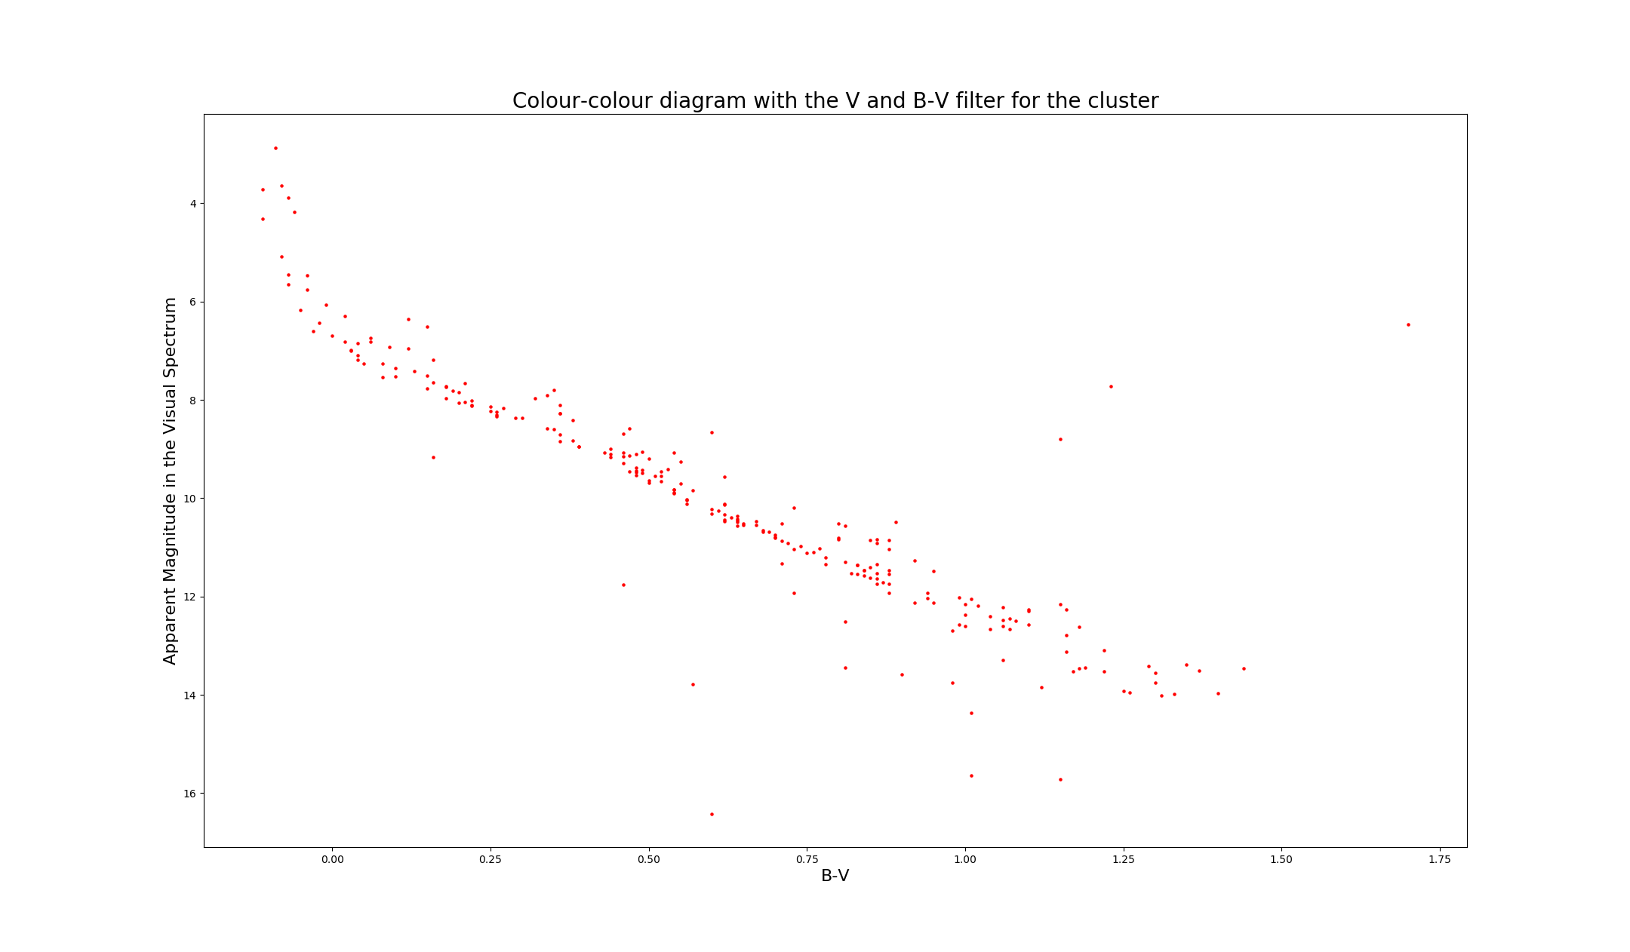By just plotting the data given, and inverting the apparent magnitude axis to follow custom, the cluster plots as follows

As it can be seen, most stars reside in the main sequence stage, where turnoff point roughly begins at the apparent magnitude (V) of 6.5. At around where B-V is 0.80, the stars can be seen to break from the linear line of the rest of the main sequence. This is probably due to unreliable data taking at such a low apparent magnitude in the visual. To attain a good estimate in the binary frequency of the cluster, the range of stars be examined must be truncated and evaluated only where the data is the most consistent. This is because the unreliable data, which occur when B-V is more than 0.8 and where the stars turnoff from the main sequence, would contaminate the reliable data and in turn, will affect the estimated frequency of the cluster.

The stars being counted are the points that slightly deviate from the main sequence line (which in this case is a straight diagonal going in blue) but only the ones at a lower apparent magnitude (which is above the blue line). This is because, in a binary system, the apparent magnitude is higher, as the luminosity being recorded is a form of superposition of both stars. Obviously stars that deviate too much (above the orange lines) from the main sequence would not be part of the binary system and are outliers of data.

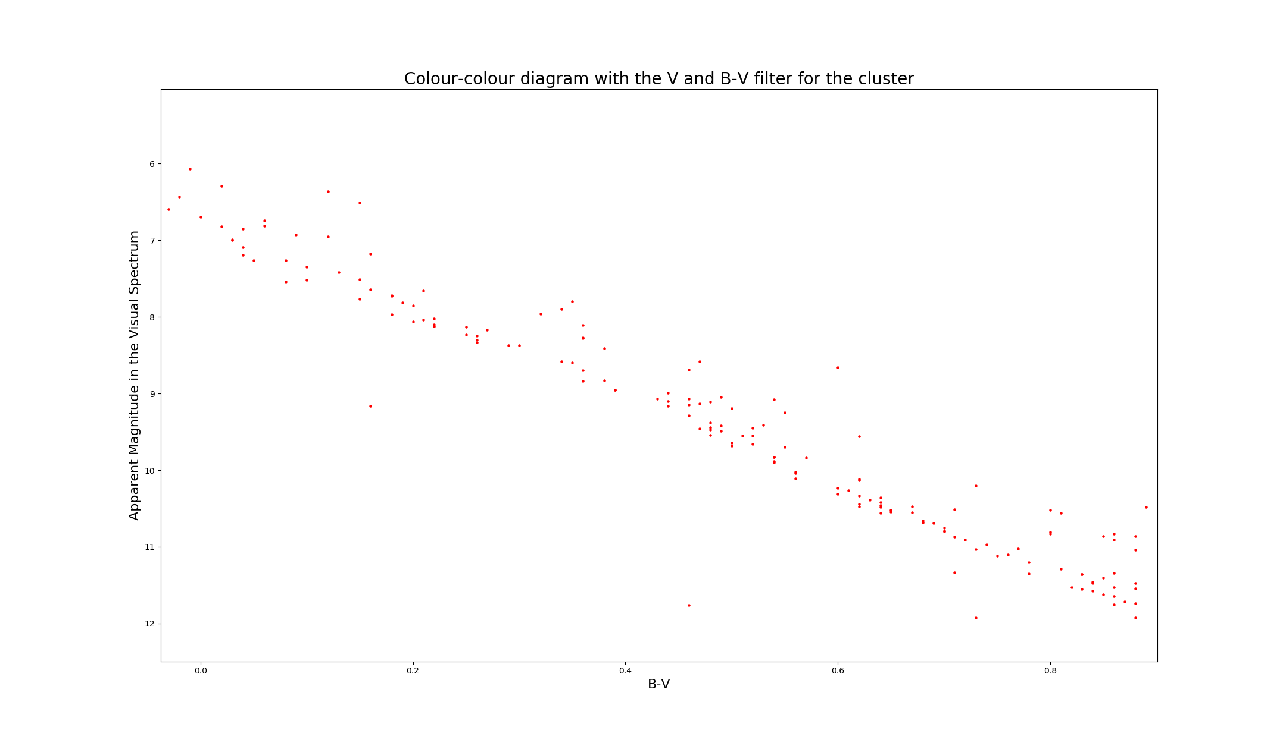

Thus, in the truncated plot, the **count of the binary stars is 32,** whereas the **total number of stars in the truncated plot is 137**

Thus, the **binary frequency for the cluster is 0.2336 or 23.36%**

## Question 2

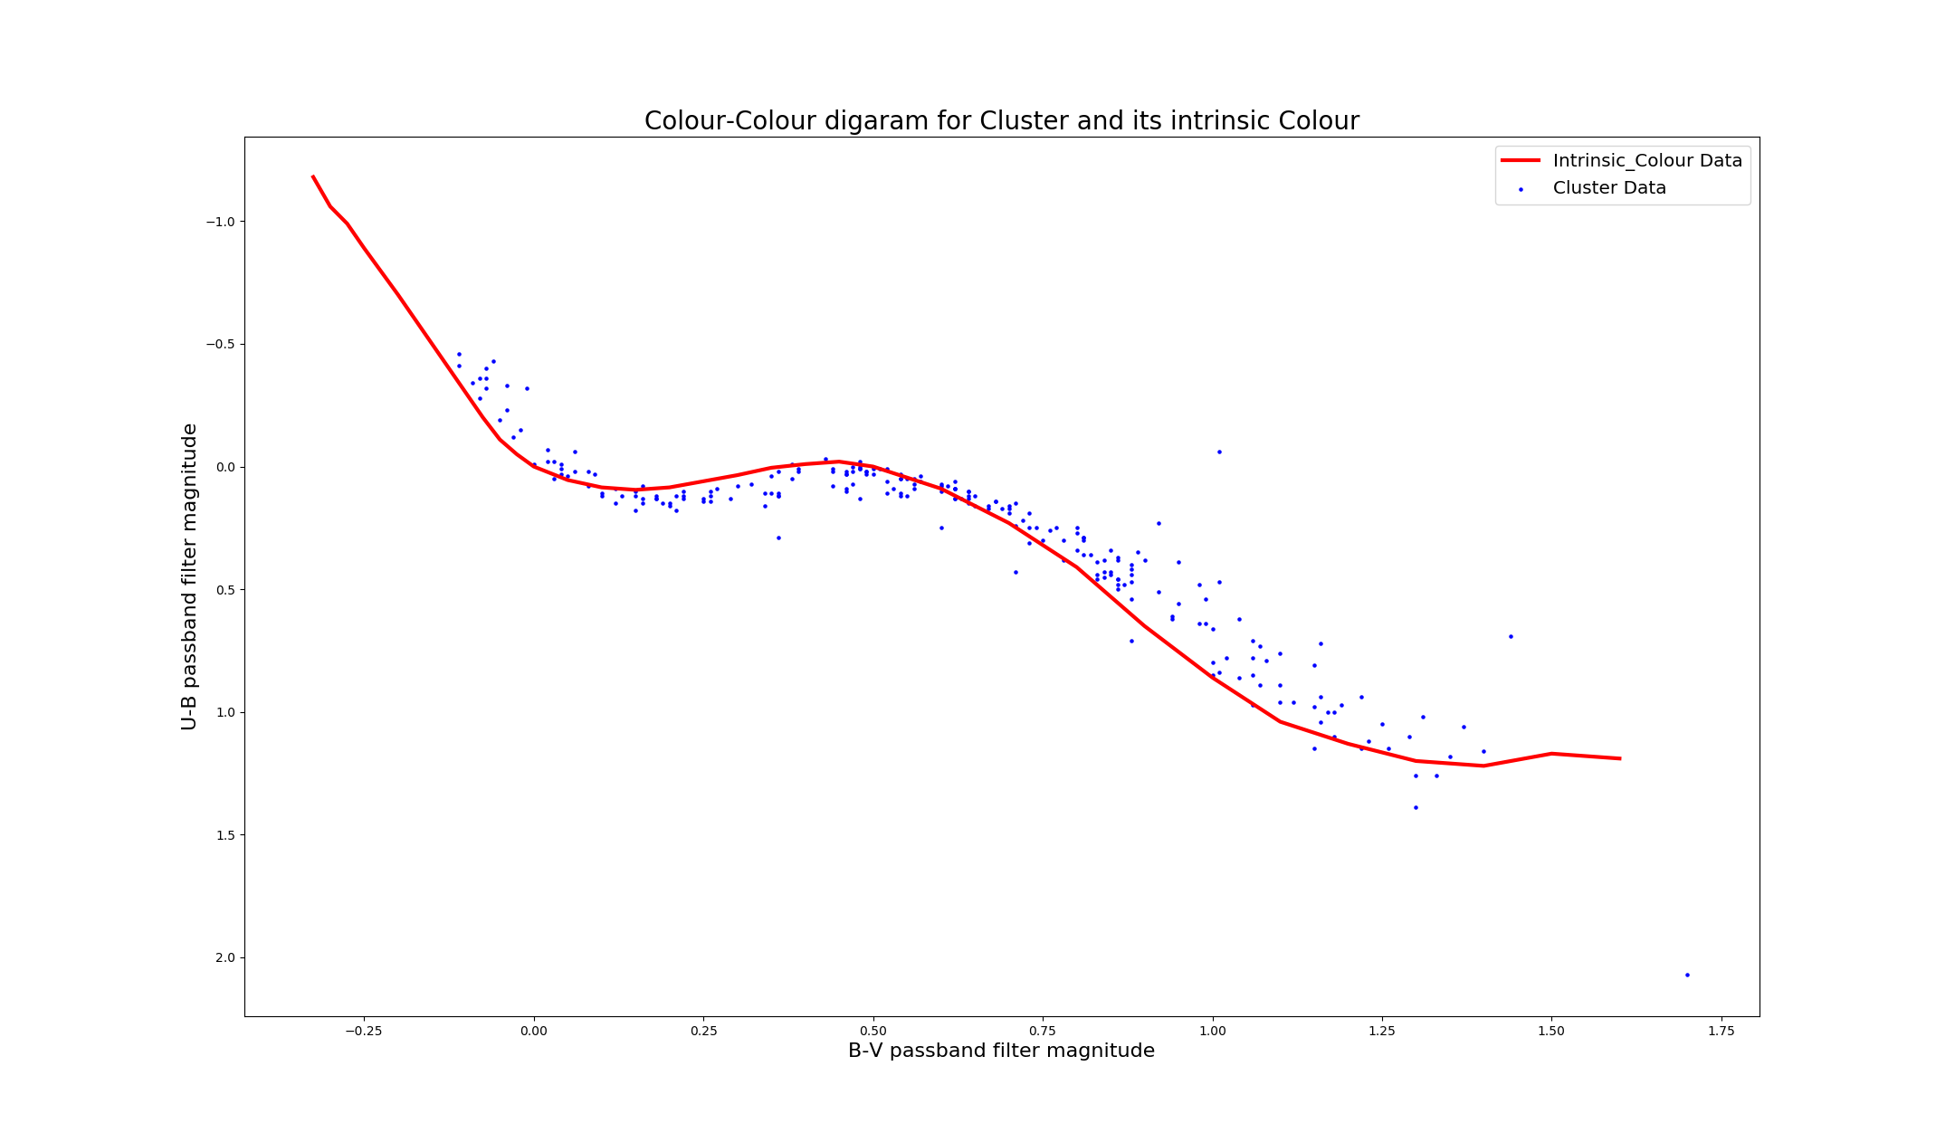Plotting the colour diagram with the intrinsic data as reference

The fact that the cluster is shifted to the right in comparison to the intrinsic data, shows that the cluster is moving away from us and in turn, is being redshifted (in the B-V passband in this case).

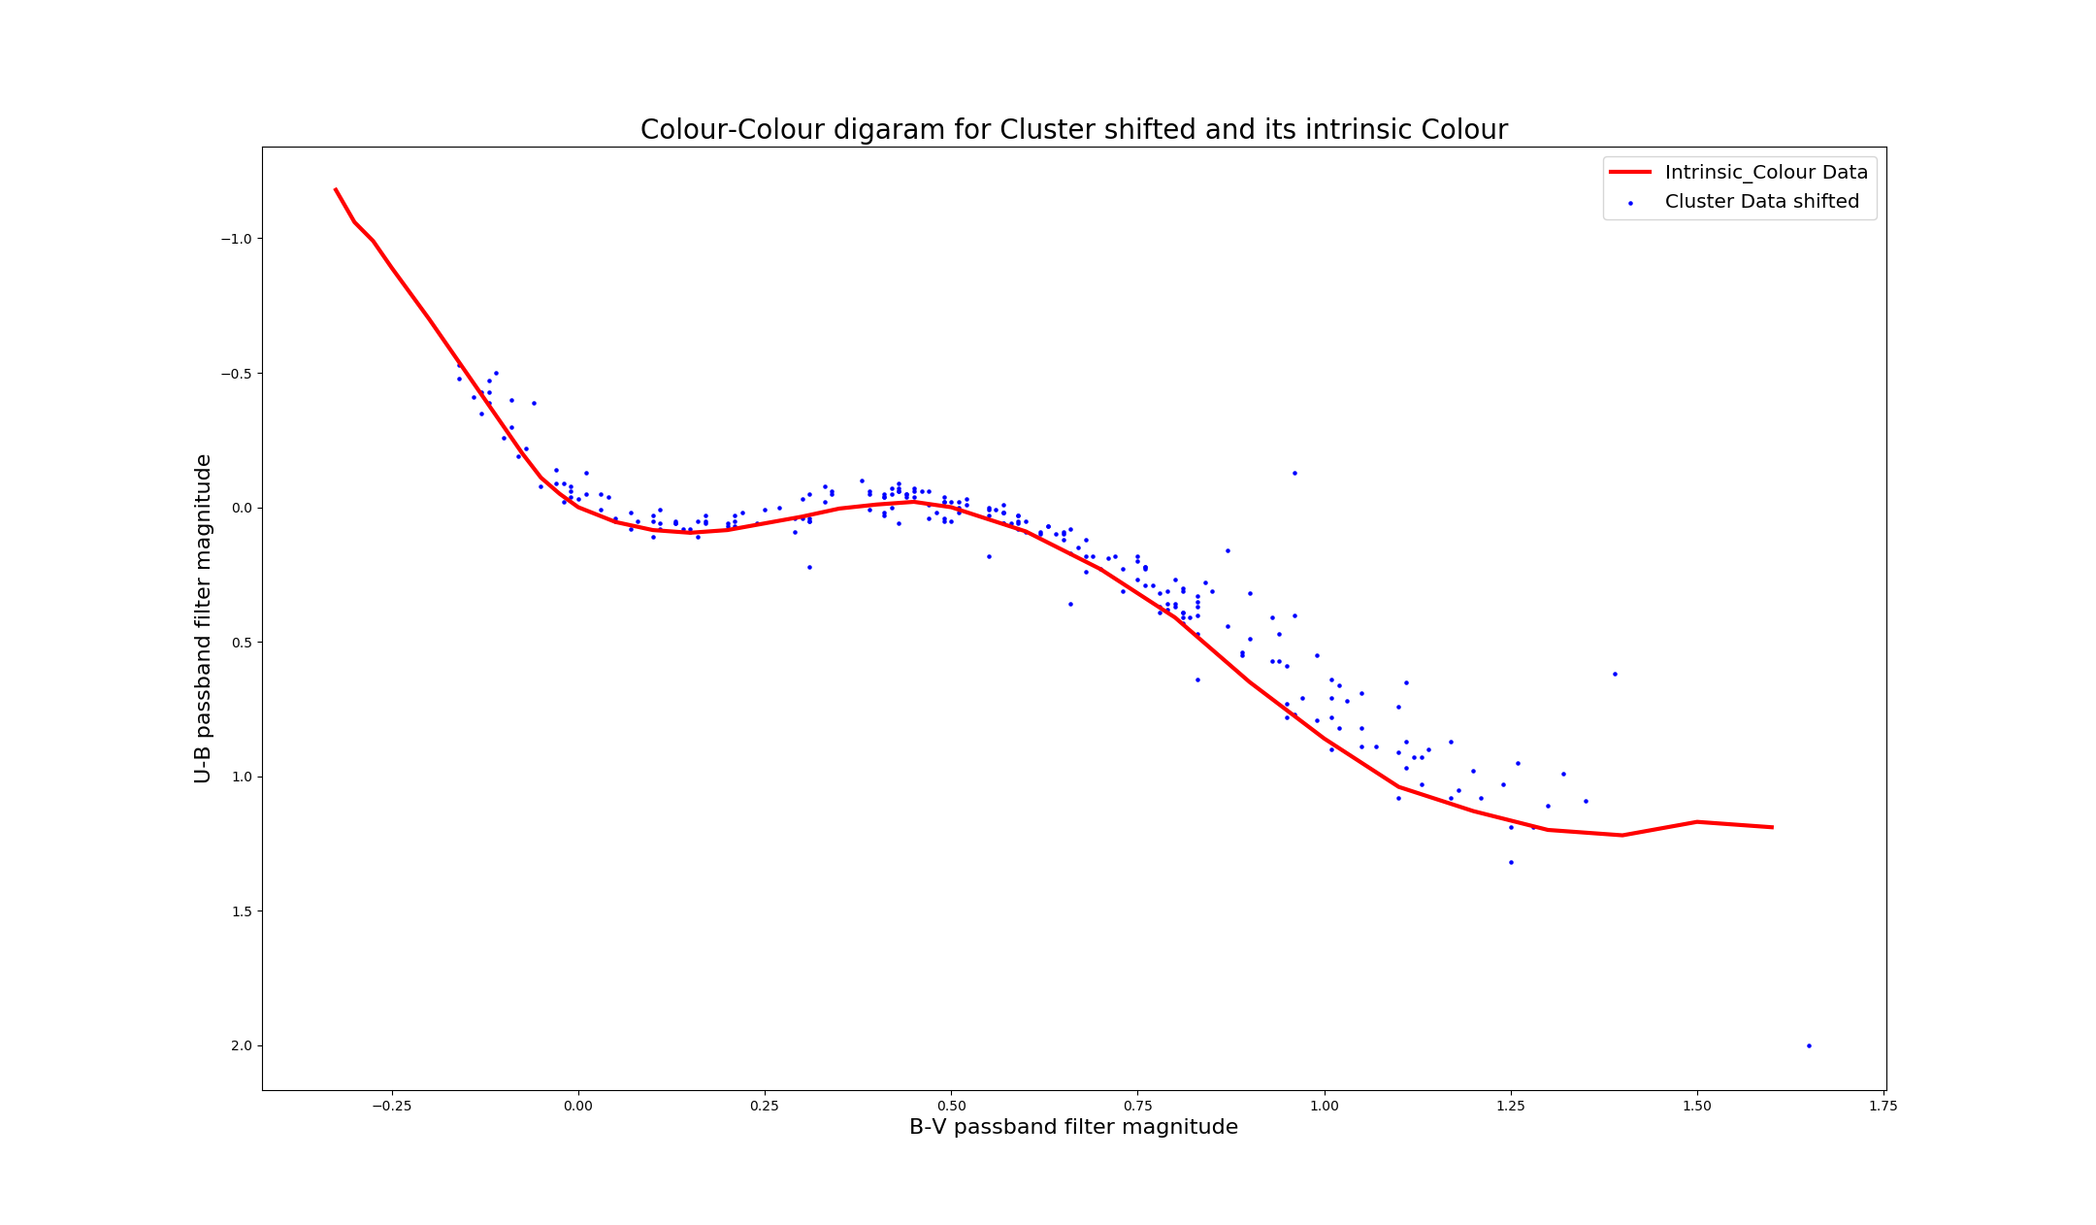From trial and error, the cluster has been redshifted by 0.05, as that is the point where both plots perfectly lie on top of each other.

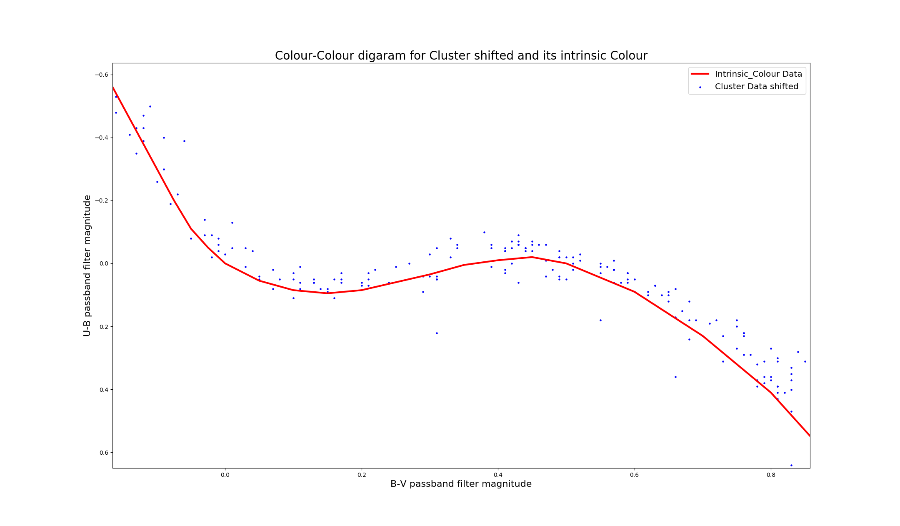Since the bottom half of the data was either not well taken or inaccurate, explains why it still does not fit the intrinsic plot. Thus, the shift was only taken to fit the top right of the data.

The fact the clusters was redshifted in the B-V spectrum indicates that it has also been redshifted in U-B spectrum. That explains as to why it was originally lower than the intrinsic data as well.

The relation is as Such:

Using that relationship, the cluster was dereddened in both spectrums.

The Extinction in the Apparent Visual magnitude (A_V) is related to the reddening of (B-V) as such:

So the **Extinction with the cluster is 0.15.**

## Question 3

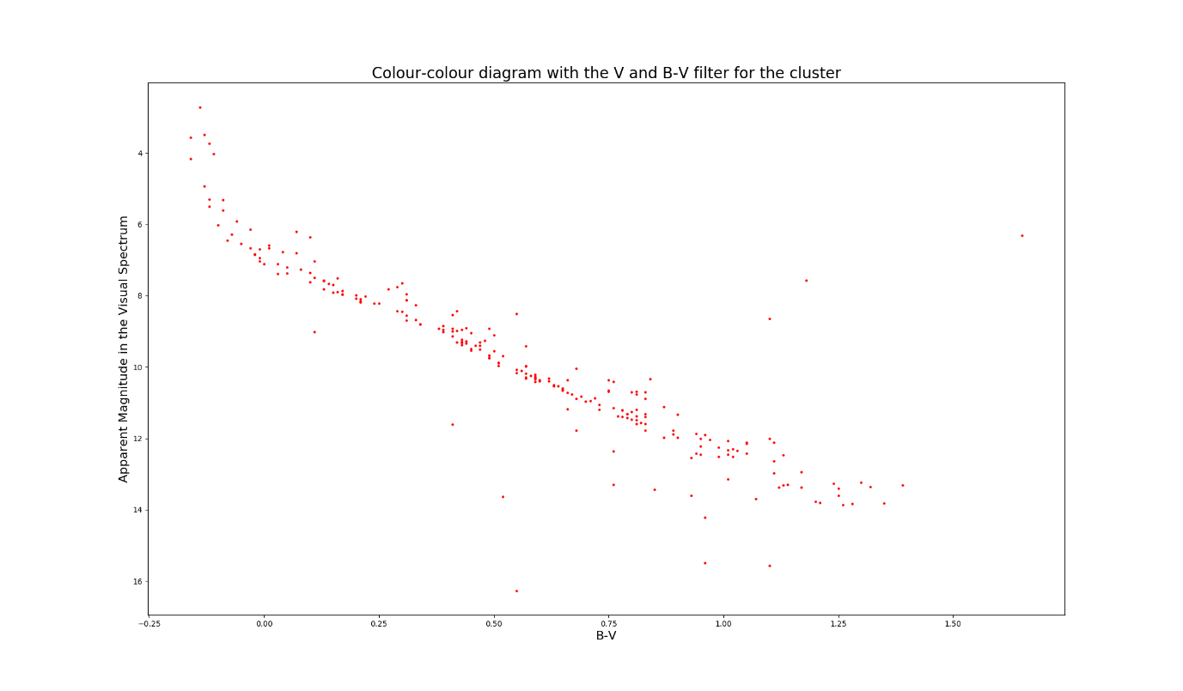Replotting the CMD with the dereddened and Extinction-corrected data

## Question 4

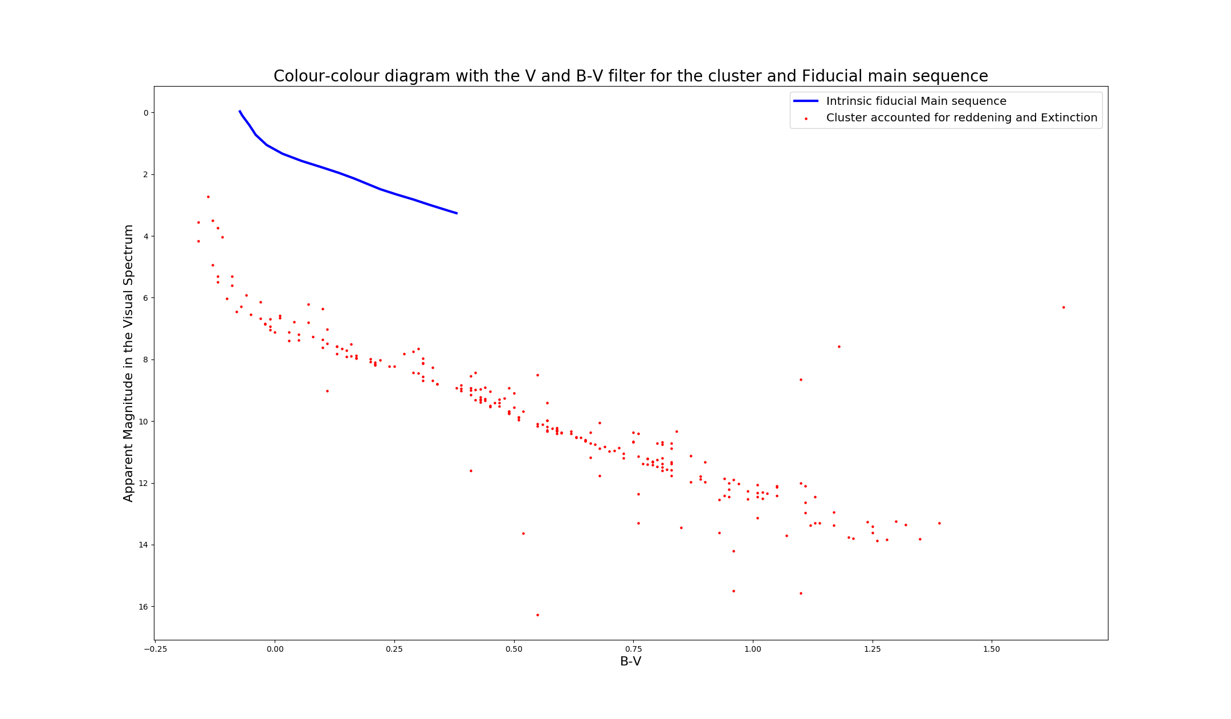Using the Fiducial Main sequence as a reference, this is the CMD without shifting

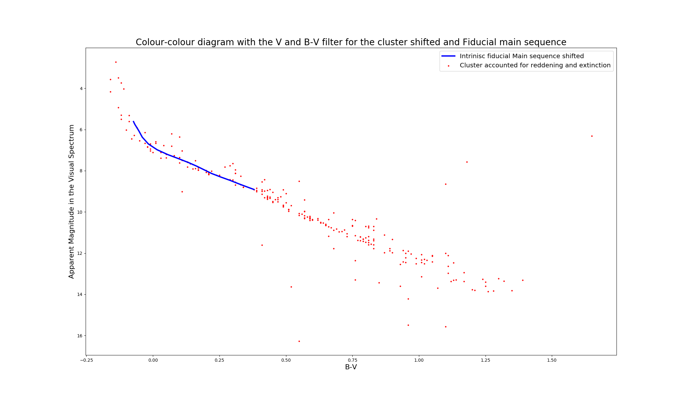The Shift of the Fiducial main sequence is the distance modulus (m-M) of the cluster as it accounts for the change of Absolute magnitude of standard, comparable, cluster and shifts it to match the recorded apparent magnitude

**The distance modulus of the cluster, the shift of fiducial Main sequence is: 5.65**

Knowing that the relation between the distance to the cluster and distance modulus is formed as below:

Where d is the distance in pc

Thus, d is:

The **distance to the cluster is 126.33 pc.**

## Question 5

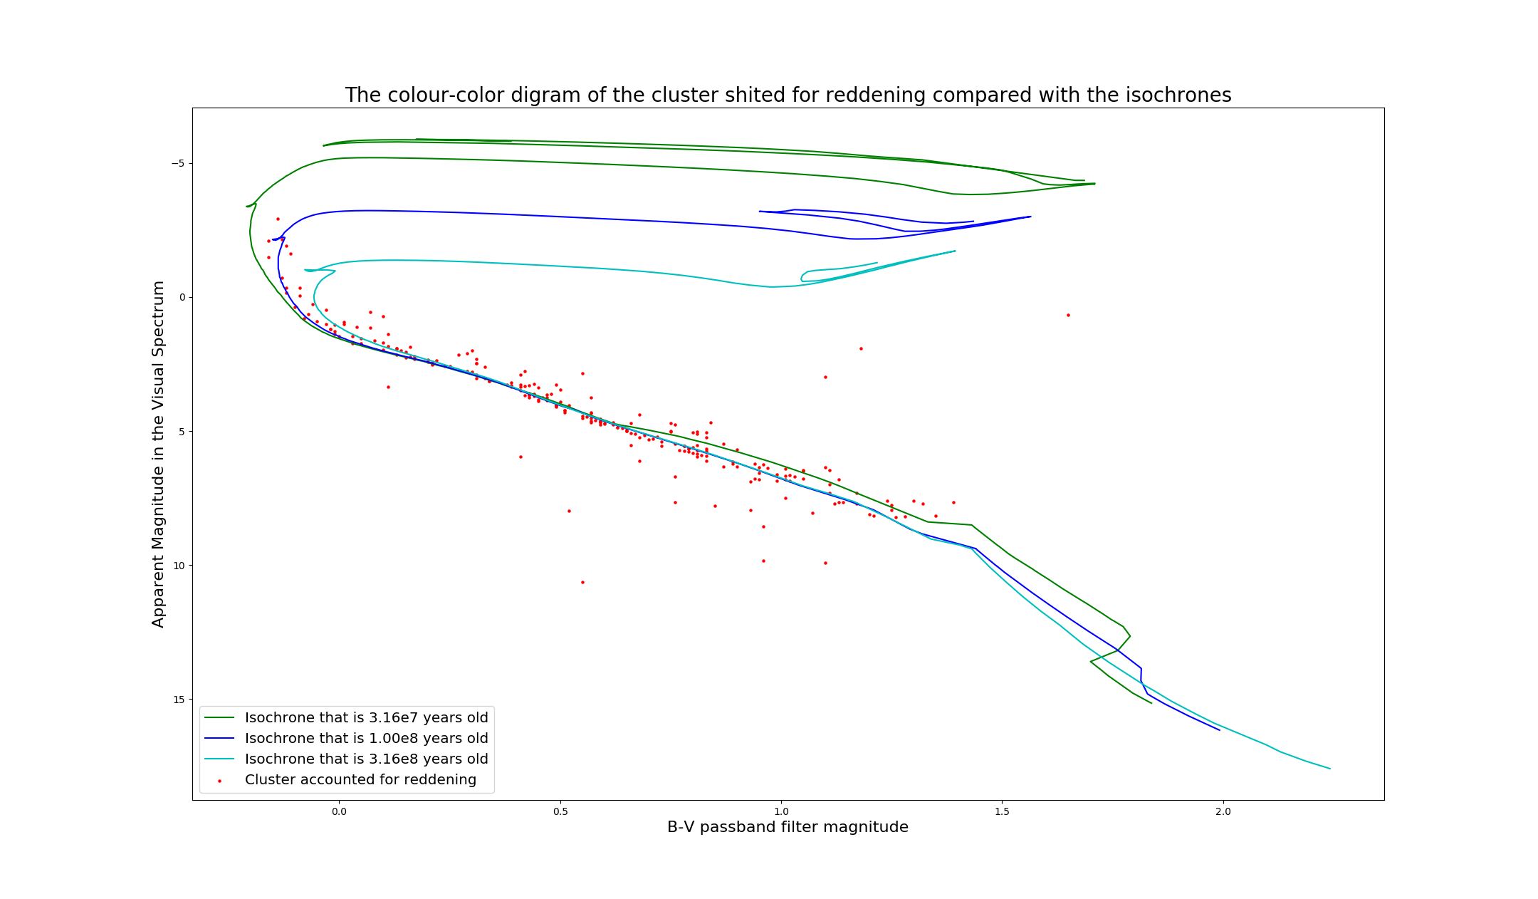By plotting the isochrones given with the dereddened (but not Extinction-corrected) cluster, the following CMD emerges

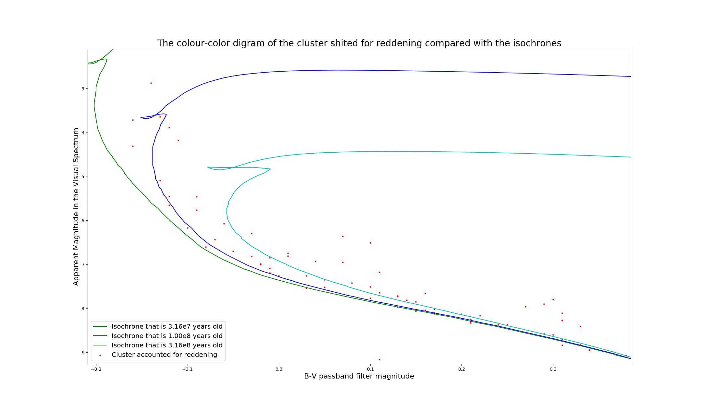

The clusters look like it clearly fits the 100 Million-year-old isochrone the best

## Question 6

As it can be seen, in the lower main sequence, the young isochrone is much higher than the other two isochrones or the data, making it not such a good fit. This is likely due to the fact that in such a young phase of cluster the protostars (less than 3 ) in clusters end their phase of rapid contraction and become T Tauri stars, which are very luminous. The stars begin to contract but much slower. This would explain why lower mass stars would have much lower apparent magnitudes around the same B-V. However, as the stars continue to contract, the become much less luminous over time.

## Question 7

The age of the dinosaurs ended around 65 million years ago. 100 Myr we were in the mid Cretaceous period. The Dinosaurs still existed at the time.

## Question 8

Due to the age of cluster, no star should have completed their evolutionary cycle, and in turn, the cluster should not contain any white dwarfs, neutron stars etc.

Due to the relatively young age of the cluster, the distance towards the cluster, and the fact that the data becomes unreliable and “messy” around the main sequence, most likely due to dust and such obscuring the data collection, it can be assumed that the cluster is an open cluster rather than Globular. This indication suggests that the stars are low in mass (maximum being ) and radial velocity. The cluster is within the plane of the disk. The metallicity of the stars are similar to the sun. and the Cluster has an outline spiral structure.